Ruthvika & Sai are National Champions
J. R. Shridharan I Vijayawada I 06-02-15

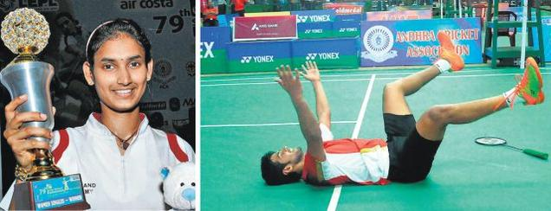
(Ruthvika Shivani...the Women's Winner (left).
Sai Praneeth celebrates his victory over Sameer Verma in the Men's final)
B. Sai Praneeth of Petroleum Sports Promotion Board and Ruthvika Shivani of Telangana emerged the Men’s and Women’s Champions in the Air Costa 79th Senior National Badminton Championship on Thursday.
Sai Praneeth snatched victory, squeezing past a fighting Sameer Verma of Air India. Sai Praneeth was pushed all the way but pulled off a 19-21, 21-15, 22-20 win over the fleet-footed Verma in a pulsating 75-minitue tussle to bag his maiden title.
Verma took an 18-13 lead and went on to win the first game 21-19. The second game saw Sai Praneeth breaking away quickly to take a six-point lead to clinch the equaliser 21-15. The decider had all the thrills of a summit clash as Both were neck and neck at 14-all, 17-all, 19-all and right down to 20-all. The final act saw a flurry strokes from both shuttlers amidst vociferous crowd support, and it was the PSPB shuttler who eventually emerged triumphant.
The Women’s final between Ruthvika Shivani and Rituparna Das, both from Telangana, was a grossly one-sided affair. The tall Ruthvika dominated proceedings right from the start. At 6-all, she surged ahead to run up a 16-10 lead, and won the first game 21-13.
Though Rituparna took a 7-2 lead in the second, Ruthivika’s brillaint all-court craft saw her take control and shut out her sparring partner by winning it 21-13 for her maiden senior National Title.

The Men’s Doubles honours went to Manu Attri (AAI) and Sumeeth Reddy (AP), who defeated Prannav Chopra (PSPB) and Akshay Dewalkar (AI) 17-21, 21-13, 21-17.
Arun Vishnu and Aparna Balan of PSPB won the Mixed Doubles defeating K. Tarun and Sikki Reddy of AAI 21-16, 11-21, 21-15.
Results (Finals)
Men’s Singles: B. Sai Praneeth (PSBP) bt Sameer Verma (AAI) 19-21, 21-15, 22-20.
Men’s Doubles: Manu Attri (AAI) & Sumeeth Reddy (AP) bt Prannav Chopra (PSPB) & Akshay Dewalkar (AI) 17-21, 21-13, 21-17.
Women’s Singles: Ruthvika Shivani (Tel) bt Rituparna Das (Tel) 21-13, 21-13.
Women’s Doubles: Sikki Reddy & Pradnya Gadre (AAI) bt Aparna Balan & Prajakta Sawant (PSPB) 21-12, 16-21, 21-18.
Mixed Doubles: Arun Vishnu & Aparna Balan (PSPB) bt K. Tarun (PSPB) & Sikki Reddy (AAI) 21-16, 11-21, 21-15.
--------------------------------

